**[TSOP1738](http://www.engineersgarage.com/content/ic-tsop1738" \o "IC TSOP1738)**

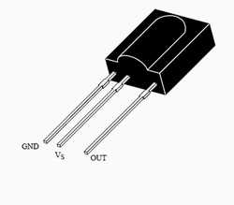

The TSOP 1738 is a member of IR remote control receiver series. This IR sensor module consists of a PIN diode and a pre amplifier which are embedded into a single package. The output of TSOP is active low and it gives +5V in off state. When IR waves, from a source, with a centre frequency of 38 kHz incident on it, its output goes low.

Lights coming from sunlight, fluorescent lamps etc. may cause disturbance to it and result in undesirable output even when the source is not transmitting IR signals. A bandpass filter, an integrator stage and an automatic gain control are used to suppress such disturbances.

TSOP module has an inbuilt control circuit for amplifying the coded pulses from the IR transmitter. A signal is generated when PIN photodiode receives the signals. This input signal is received by an automatic gain control (AGC). For a range of inputs, the output is fed back to AGC in order to adjust the gain to a suitable level. The signal from AGC is passed to a band pass filter to filter undesired frequencies. After this, the signal goes to a demodulator and this demodulated output drives an npn transistor. The collector output of the transistor is obtained at pin 3 of TSOP module.

Members of TSOP17xx series are sensitive to different centre frequencies of the IR spectrum. For example TSOP1738 is sensitive to 38 kHz whereas TSOP1740 to 40 kHz centre frequency.

**Pin Diagram:**

